Cross Country Is Back at Newton
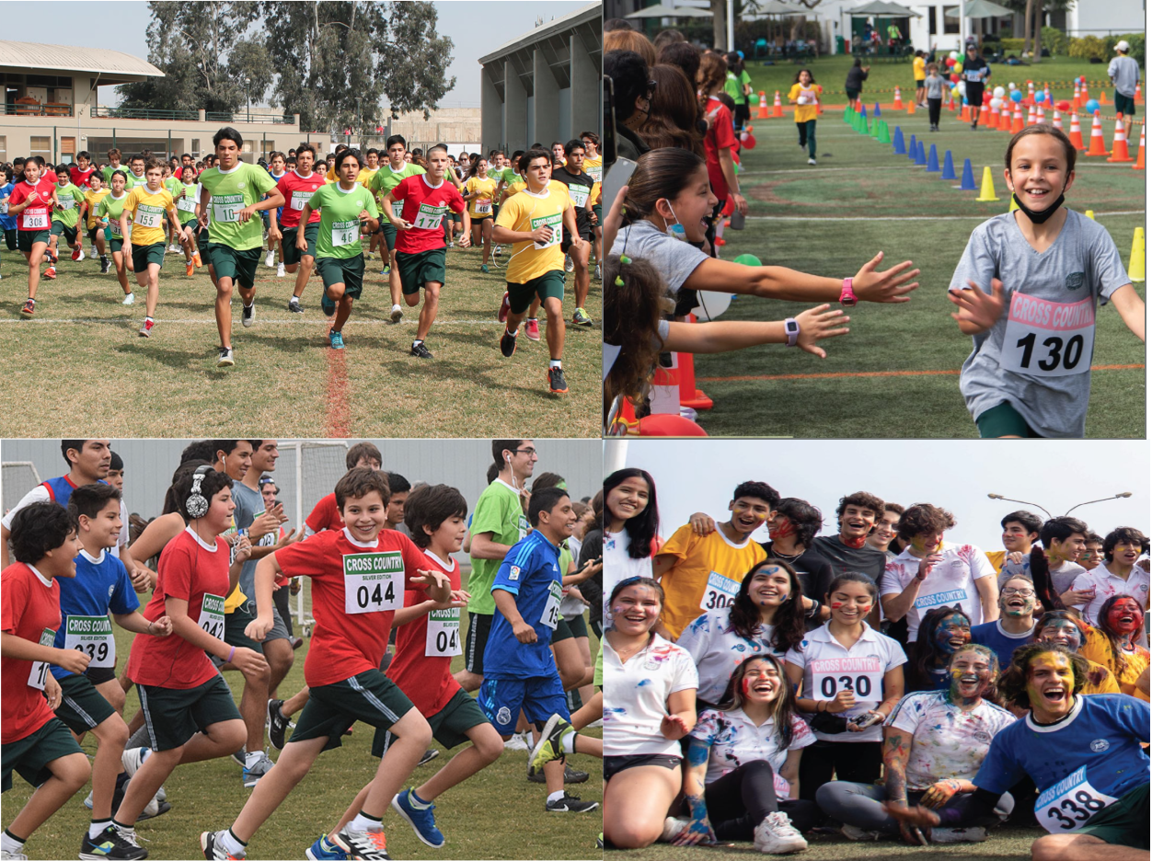
By Micaela Alzamora - Form V

After a long time, one of Newton’s most anticipated interhouse events is finally coming back: cross country. This year, the Student Council has been working on new ideas to bring more energy into house activities, and the return of this event is already creating excitement across the school community.
Cross country is an interhouse competition where students and their families can represent their colours while completing a route of approximately 3.8 kilometers. The race begins on campus, continues outside the school through Pasaje El Marino, and includes a lap around the nearby lake before students re-enter the school, crossing the finish line on the track field where everyone is waiting. This makes the event not only physically challenging but also a unique experience that goes beyond a typical school activity.
One of the most exciting aspects of this year’s return is the participation of Form V students. For them, cross country is not only about competing, but also about celebrating their final year. Many seniors take part more festively, often running together, playing music, and even painting themselves, creating a more memorable atmosphere.
The return of cross country is especially meaningful this year because it has not taken place in recent years. Its comeback reflects a broader effort by the Student Council to revive interhouse activities and strengthen house spirit within the school. Although many interhouse events are still being planned, this marks an important step toward rebuilding traditions that bring the Newton community together.
Overall, the return of cross country represents more than just a race. It is a sign of renewed school spirit and student initiative. As more activities are expected to be introduced throughout the year, students are encouraged to stay engaged and look forward to what is coming next.

